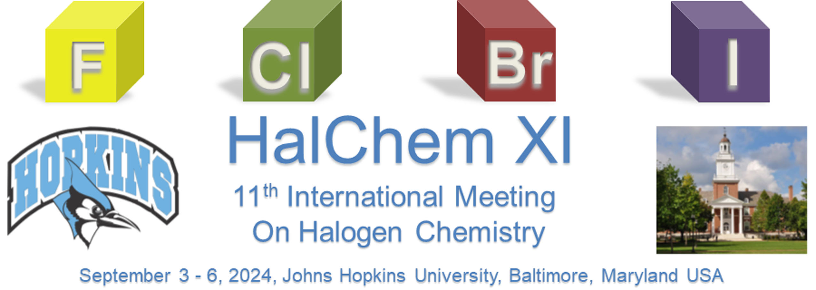

(Attendee name) Date
(institution)
(City, Country)

RE: Invitation letter

On behalf of the International Advisory committee, we are pleased to invite …(our name) …… to participate in the "11th Edition of the International Meeting on Halogen Chemistry (HalchemXI)”. This will be held in Baltimore, MD (USA) from September 3th to September 6th.

The conference will be devoted to synthetic and theoretical aspects, spectroscopy, supramolecular chemistry, halogen bonding, hypervalent halogen compounds, medicinal and biological chemistry, atmospheric chemistry, etc., and provides a unique opportunity for the scientific community working in the area of halogen chemistry to bring together information, results and ideas that will stimulate further exploration and cooperation.

All relevant information on HalchemXI is available https://chemistry.jhu.edu/halchem/
Participation by ….(our name)… will mutually benefit all conferees and help to make this event a great success. Your support in issuing an entry visas to the USA will be most appreciated.

Personal data of………(our name) …………….as follows:

Passport No.:
Valid Until:
Issued By:
First Name:
Family Name:
Nationality:
Date of Birth:
Place of Birth:
Sex:

This letter does not constitute any financial obligation on behalf of the Organizers

Sincerely yours,

_______________________
Steven Rokita, Professor of Chemistry
Johns Hopkins University
Chairman of the "11th Edition of the
International Meeting on Halogen Chemistry (HalchemXI)"

